**Fun & Games with**

**The Easter Bunny**



**Sat, March 23, 2024**

**10am – 12noon**

**This is a free event for children up to age 12**

**1012 Bell Avenue – Glen Burnie, MD 21060**

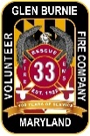**410-793-2709**

https://www.ppsia.org/uploads/1/2/3/1/123188129/ppsia-logo.png

**Hosted by:**

**Glen Burnie Volunteer Fire Company and**

**Point Pleasant Shoreland Improvement Association**